Planning Document

Client Requirements

The client would like for us to develop a database that can later be used as a source of info for the mobile and web apps. This database will contain reference materials for students. It will hold articles on three subjects: art, mathematics and technology. Each subject’s articles can contain biographies of key people, as well as articles on the major art objects, events and important notions.

This database may be accessed by administrators, tutors and students, so it will need various access levels;

* Students should be able to:
  + Browse articles by category
  + Browse articles by keyword in title
* Tutors should be able to:
  + Add or modify articles
* Administrators should be able to:
  + Add, modify or remove articles

Possible Solutions

* Django + SQL
* Django + Mongo
* SQL

Chosen Solution

SQL

Timeline

* Iteration 1 = 21/02/2019
* Iteration 2 = 26/02/2019
* Iteration 3 = 27/02/2019
* Iteration 4 = 28/02/2019

Iterations

* Iteration 1: Developing System Design document
  + Analyse the data and create Solution Design document outlining Architecture, Database Model, User Access and UX Design.
  + For each part of the Solution Design document, provide reasons of selecting technologies or choosing specific design.
* Iteration 2: Developing the Database
  + Create the database in the approved database management system.
  + Follow the approved database model to create the appropriate database structure.
  + Enter the test data provided.
* Iteration 3: Developing Database Queries
  + Create and test the appropriate queries as per client requirements.
    - Browse articles by category
    - Browse articles by keyword (in title)
    - Remove articles
    - Add articles
    - Modify articles
* Iteration 4: User Access Implementation Suggestions
  + Create suggestions on implementing the user access in the approved DBMS.

Kanban Board / Trello

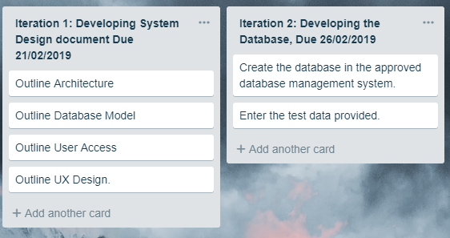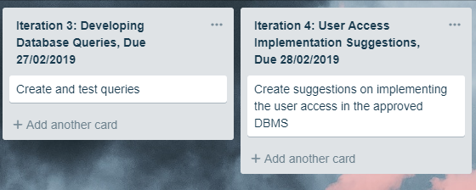

Client Feedback

Client gave the all clear, no changes needed.

Changes to Planning Document:

Detailed Iteration steps:

Iteration 2: Developing the Database

1. Set up your development environments.
2. Set up and test your GitHub repository. Create a ReadMe file.
3. Create the database in the approved database management system. Follow the approved database model to create the appropriate database structure.
4. Enter the test data provided. Test the data recorded and displayed correctly.
5. Make sure your GitHub repository has the latest version of the database.
6. Show the database to the client and get client’s approval.

Iteration 3: Developing Database Queries

1. Design, code and unit test appropriate queries to support user stories per client requirements.
2. Perform functional testing using a test plan, record test results and bugs found in a Testing document. It is most effective to test each other’s features.
3. Fix critical/major bugs.
4. Make sure your GitHub repository has the latest version of the database.
5. Show the queries to the client and get client’s approval.

Iteration 4: User Access Implementation Suggestion

**User Access, Roles and Privileges:**

1. While using MySQL Workbench; to create users click on the server drop down at the top of the screen.
2. Click Users and Privileges.
3. Click add account and choose a username and password (following ser password requirements, as stated in Solution Design document).
4. Click on the account limits tab and alter the number of queries and concurrent log-ins the user is allowed.
5. Click on the administrative roles tab and assign what functions the user can perform in their queries.
6. Click apply and the user is saved with set permissions.

Packaging

Once all code has been merged and the database is stable, download the final version of the code into a zip file, ready for submission.

## New Updated Kanban / Trello Board

